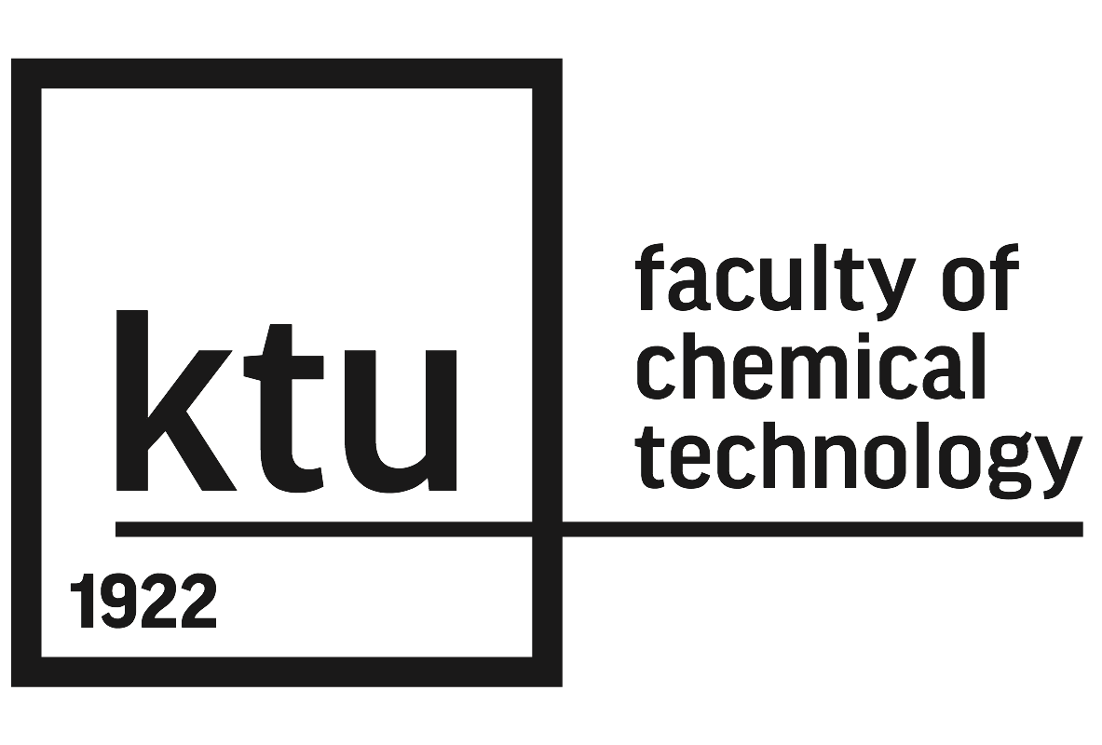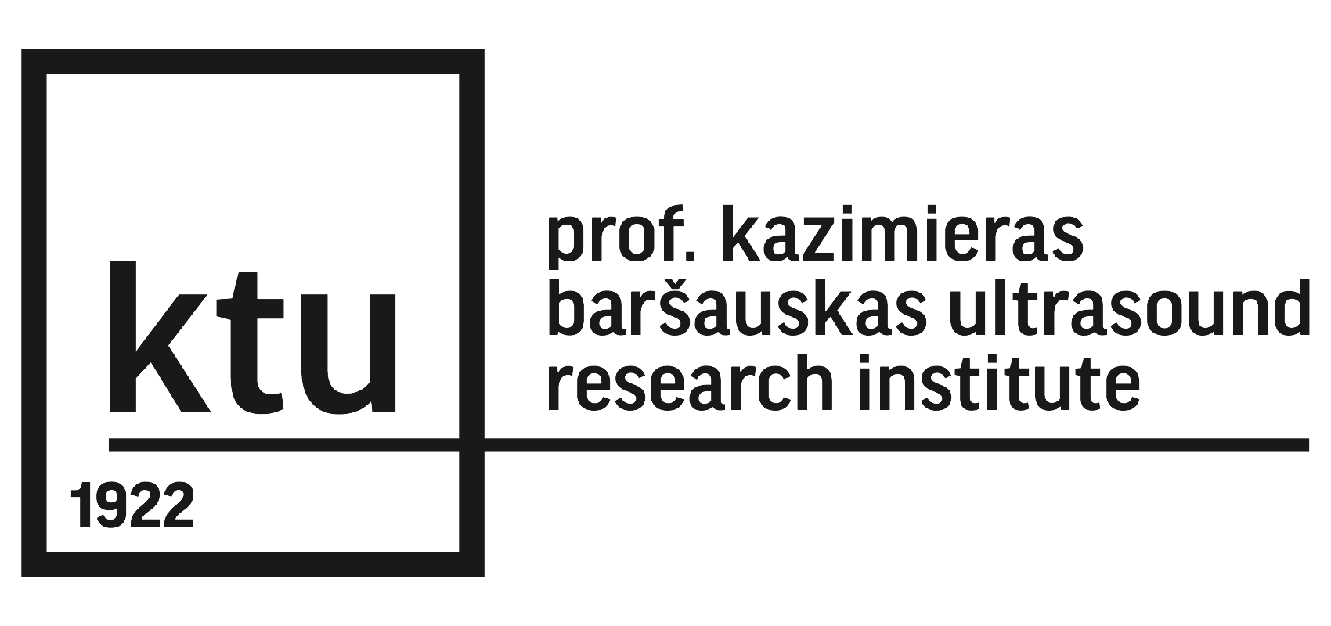
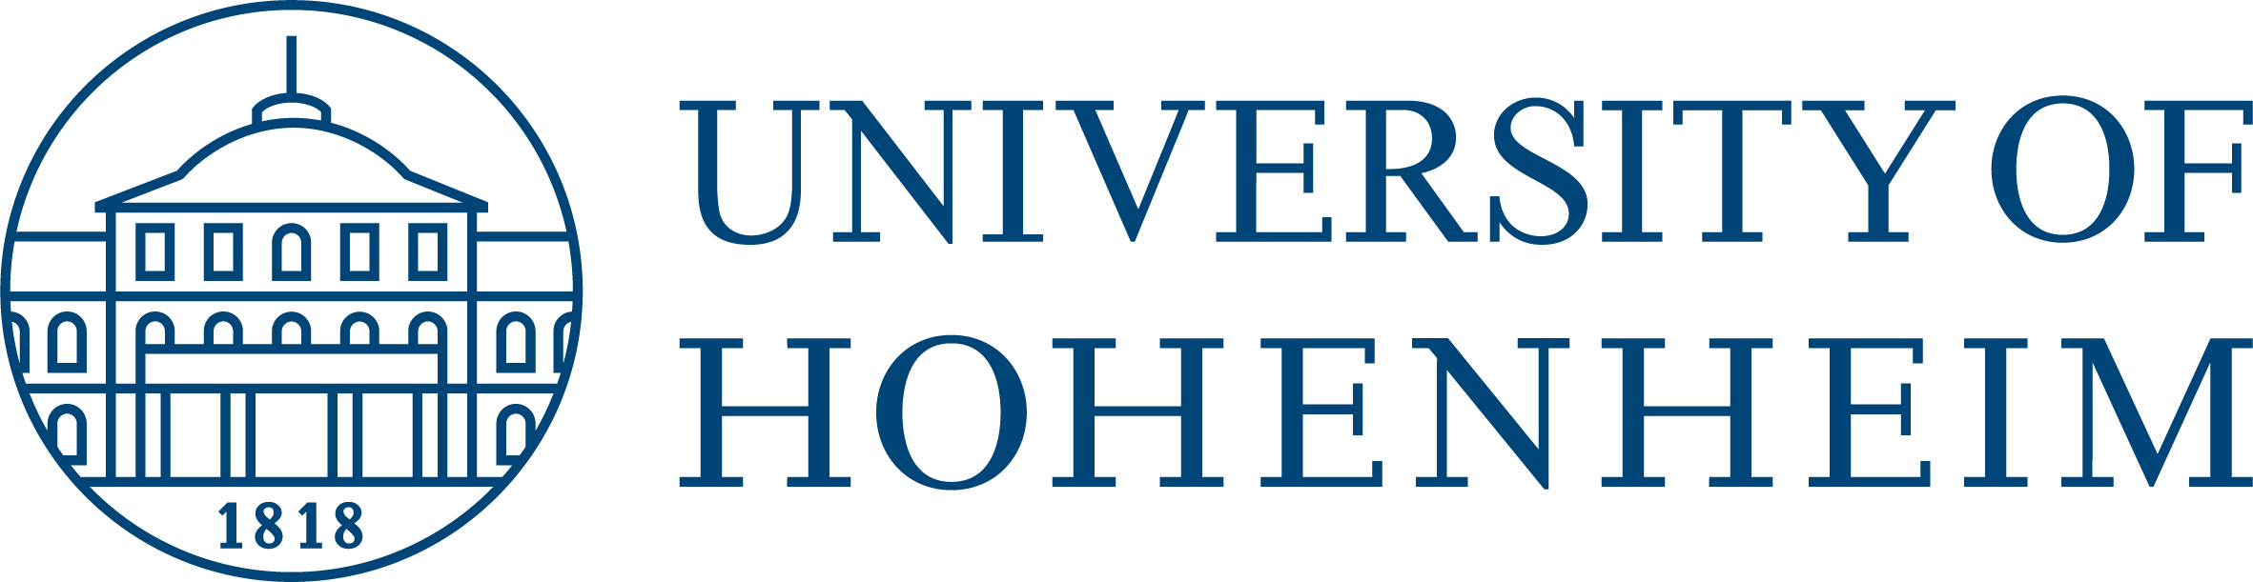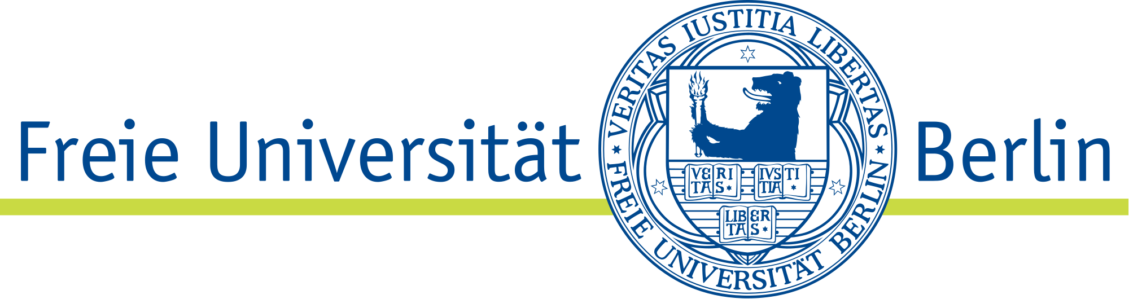

International seminar “Towards sustainable meat technology that environment and consumer requires”
Place and data
2018-09-28, 9.00 a.m. Kaunas University of Technology, Radvilėnų str. 19, building B, room 205
Seminar guests
Zebeli Qendrim, Univ.-Prof. Dr.sc.agr.
Institute of Animal Nutrition and Functional Plant Compounds,
Chair of Institute
University of Veterinary Medicine, Austria

Dr. R. Puntigam, Slama Julia Andrea, Dipl.-Ing
Institute of Animal Nutrition, Livestock Products, and Nutrition Physiology (TTE)
University of Natural Resources and Life Sciences, Vienna

Apl. Prof. Dr. sc. agr. habil. Michael A. Grashorn
Institute of Animal Science
Livestock Population Genomics
University of Hohenheim

Dr. med.vet. Ilen Röhe
Institute of Animal Nutrition
Freie Universität Berlin

Seminar participants

Dr. Alvija Šalaševičienė, Dr. Galina Garmienė, Habil. Dr. Joana Šalomskienė, Prof. Habil. Dr. Romas Gružauskas
Food Institute
Kaunas University of Technology

Dr. Edvinas Krugly
Department of Environmental Technology
Kaunas University of Technology

Assoc. Prof. Dr. Joana Bendoraitienė, Assoc. Prof. Dr. Ramunė Rutkaitė
Department of Polymer Chemistry and Technology
Kaunas University of Technology

Assoc. Prof. Dr. Bašinskienė Loreta
Department of Food Science and Technology
Kaunas University of Technology

Dr. Tadas Prasauskas
National Innovation and Entrepreneurship Centre
Kaunas University of Technology

Prof. Dr. Renaldas Raišutis
Prof. K. Baršauskas Ultrasound Research Institute
Kaunas University of Technology

Short presentation

“Knowledge transfer and entrepreneurship promotion at Kaunas University of Technology” - Dr. Tadas Prasauskas, Technology Transfer Project Manager, National Innovation and Entrepreneurship Centre, Kaunas University of Technology

“Studies, Research and Innovations in the Department of Food Science and Technology of Kaunas University of Technology” - Assoc. Prof. Dr. Loreta Bašinskienė, Head of the Department of Food Science and Technology, Kaunas University of Technology

“Research activities and possible scientific collaboration with Food Institute of Kaunas University of Technology” – Dr. Alvija Šalaševičienė, Director of Food Institute, Kaunas University of Technology
“Plasma methods for preservation of raw materials of animal origin and emission control in the poultry production” – Dr. Edvinas Krugly, Department of Environmental Technology, Kaunas University of Technology

“Ultrasound possibilities for evaluation of poultry meat quality and other products” - Prof. Dr. Renaldas Raišutis, Prof. K. Baršauskas Ultrasound Research Institute, Kaunas University of Technology

“New trends in the meat products packaging” - Assoc. Prof. Dr. Ramunė Rutkaitė, Department of Polymer Chemistry and Technology, Kaunas University of Technology

Topics of the seminar to be discussed:

Gut health and product quality
New methods for evaluating and preserving quality of the meat
Research possibilities in proteomic area
Scientific projects and collaboration possibilities
Possibility to organize scientific conference “Gut health and product quality” in April 2019

10.45 – 11.15 Visiting laboratories and departments of the Faculty of Chemical Technology of Kaunas University of Technology

11.30 – 12.00 Visit to Prof. K. Baršauskas Ultrasound Research Institute of Kaunas University of Technology

Lunch

13.00 – 13.30 Visit to Institute of Materials Science of Kaunas University of Technology

